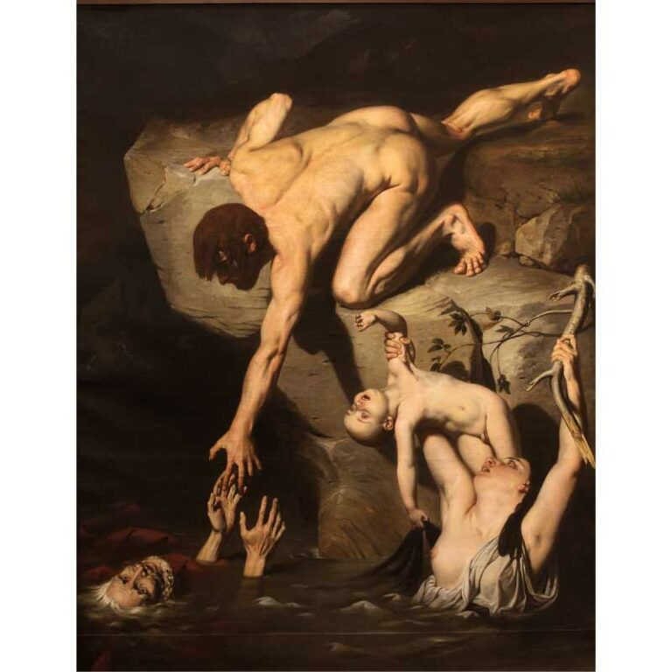

Scene of Deluge

Joseph-Désiré Court

James: This painting seems interesting in some ways I personally cannot understand.

Joseph Court: Interesting, huh? This painting depicts a man rescuing his father from the raging waters, instead of the typical depiction of a man saving his wife and son.

James: So that drowning old man is his father, that drowning woman is his wife and that baby she’s carrying is his child. He could easily save the baby if he wanted to. Why is he trying to save the old man first when he clearly seems to slip out of his grip?

Joseph Court: It's possible to view the father as a representation of the past, the wife as his present, and the son as his future. A young man ignores the prospects that lie ahead and clings to his past, neglecting what he has right now. As a result of his choice, he not only loses his child and wife but also his father who is just out of reach.

James: So, he who always clings to his past will probably lose his present and future. It is actually kind of deep, huh? Thanks for the chat old man. Who are you, by the way?

Joseph Court: Glad to help, kid. I am Joseph-Désiré Court and I am the painter of this artwork.

**|End of Conversation|**